HP LP2065 Flat Panel Monitor
Flagship quality for advanced users.

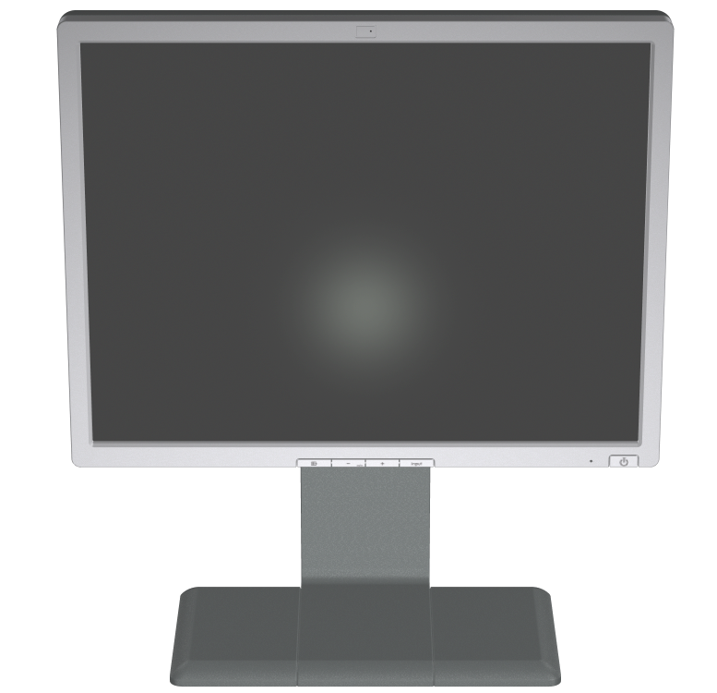

The HP LP2065 Flat Panel Monitor is ideally suited for workstation and high-end business users. This flagship model provides sharp resolutions up to 1600 x 1200 on a 20.1-inch viewable screen. Advanced features include extra-wide viewing angles, super-thin bezels, multiple inputs (analog and digital), fast response times, built in USB hub, and height-adjustable base with pivot rotation.
Advanced features
This monitor offers superior clarity with an extra-bright screen, 800:1 high contrast ratio, superior image processing, and 178-degree viewing angles. The
anti-glare coating and flicker-free presentation meet the TCO 03 requirements specified by The Swedish Confederation of Professional Employees. The integrated power supply eliminates bulky "power bricks" and improves cable management for easy mounting on the wall or on an arm. The new HP Display Assistant software utility allows monitor adjustment, color calibration, and security/asset management through the Display Data Channel Command Interface (DDC/CI) protocol of the connected desktop PC instead of the monitor's on-screen display (OSD). HP Display LiteSaver technology helps increase monitor life and reduce power consumption by enabling users to schedule low-power Sleep mode at pre-defined times.
User-friendly features and superior ergonomics
A height-adjustable base and 90-degree pivot capability for portrait or landscape viewing make it easier to achieve comfortable eye contact with the screen. The detachable base simplifies mounting, handling, and shipping. Super-thin bezels on all four sides of the screen let you "tile" multiple panels together for a panoramic video array of large amounts of data and information, which can be especially useful on trading floors or in other data-intensive environments.
Investment protection
The HP LP2065 comes equipped with a variety of inputs for enhanced flexibility, including dual DVI-I, which allows the monitor to be used in either dual analog mode or dual digital mode. The built-in USB hub enables easy compatibility with a variety of peripherals, including the optional USB-powered HP Silver Flat Panel Speaker Bar (sold separately), which adds speakers to the desktop by attaching easily to the base of the monitor.
Versatile design
The HP LP2065 monitor features the new HP Quick Release, which allows the monitor to be quickly and easily mounted on a wall, arm, or another VESA-compliant device. HP Quick Release enables uniquely flexible product configuration alternatives in a variety of settings, including storefronts, kiosks, trade shows, training labs, and medical and institutional settings.
Environmentally friendly
HP helps protect the environment by designing for low emissions using recyclable plastics while limiting heavy metals or other potentially harmful elements. Unit design also complies with Energy Star for environmental friendliness and power savings.
Quality and reliability
HP monitors meet a high level of quality and reliability. The HP LP2065 monitor is fully tested and qualified internally and at external labs to assure backward and forward interoperability and compatibility with legacy, current, and in-development HP products.
Service and support
The HP LP2065 monitor is backed by a three-year warranty and comprehensive HP service and support from 65,000 IT service and support professionals in 160 countries around the world.

HP LP2065 Flat Panel Monitor
Specifications
 | Panel type | Active matrix TFT (thin film transistor); anti-glare/anti-static coatings
 | Viewable image area (diagonal) | 20.1 in (51 cm) maximum viewable area
 | Viewing angle | 178° horizontal/178° degrees vertical (10:1 min. contrast ratio) typical
 | Brightness | Up to 250 nits (typical)
 | Contrast ratio | Up to 800:1 (typical)
 | Response rate | 8 ms¹
 | Pixel pitch | .255 mm
 | Color depth support | 16.7 million colors
 | Frequency | Horizontal: 30 to 94 kHz (VGA input); 30 to 92 kHz (DVI input) (for modes with pixel clock less than 157 MHz)  Vertical: 48 to 85 Hz (VGA input); 30 to 92 kHz (DVI input) (for modes with pixel clock less than 157 MHz)
 | Resolutions supported | 1600 x 1200 @ 60 Hz (native); all VESA modes up to 1600 x 1200 @ 75 Hz (analog), 1600 x 1200 @ 60 Hz (digital)
 | Input signal | Two connectors, dual DVI-I (VGA analog and digital input)
 | Video cable | Two VGA to DVI-I and two DVI-D to DVI-I cables included
 | User controls (on-screen display) | Brightness, contrast, positioning, color temperature, individual color control, serial number display, full screen resolutions, clock, clock phase, video picture-in-picture (size and position), input selection (includes separate direct access key for dedicated swap between inputs 1 and 2), factory reset
 | Built-in power supply | Auto-Ranging, 90 to 132 VAC and 195 to 265 VAC; internal power supply, 50 Hz/60 Hz
 | Power consumption | < 75 watts maximum; < 2 watts power saving mode; 55 watts (without USB ports); 70 watts (USB ports fully loaded) typical
 | Dimensions (h × w × d) | Without stand: 13.58 x 17.4 x 3.42 in (34.5 x 44.3 x 8.7 cm)  With stand: 16.7 to 21.8 x 17.4 x 8.67 in (42.5 to 55.5 x 44.3 x 22.0 cm)  Packaged: 11.77 x 22.2 x 16.77 in (29.9 x 56.4 x 42.6 cm)
 | Weight | With stand: 20.28 lbs (9.2 kg); Without stand: 12.65 lbs (5.75 kg); Packaged: 26.3 lbs (11.95 kg)
 | Base features | Height adjustment, tilt, swivel, pivot rotation for portrait and landscape viewing
 | Temperature | Operating: 46° to 95° F/10° to 35° C; Non-operating: 6° to 140° F/-10° to 60° C
 | Certification and compliance | Australian ACA Approval, Canadian Requirements/CSA, CE Marking, China CCIB/CCEE Approval, CISPR Requirements, Eastern European Approvals, Energy Star Compliant, FCC Approval, German Ergonomic (TUV and GS Mark), ISO 9241-3,7,8 VDT Guidelines, ISO 13406-2 Pixel Defect Guidelines, Mexican NOM Approval, MIC Requirements (New Zealand), MPR-II Compliant, Nordic Approvals (Nemko, Fimko, Demko, Semko), PC2001 Compliant, PC99 Certified, S. Korean MIC Approval, Taiwan BSMI Approval, TCO 03 (emissions, ergonomics, environment), TUV-Ergo, UL Listed, VCCI Approvals, Windows Certification (Microsoft® Windows® 98, Microsoft Windows 2000, and Microsoft Windows XP)
 | Warranty | Three-year limited warranty parts, including backlight and on-site labor or 48 hour direct unit replacement. Certain restrictions apply; terms may vary by region
¹ Response time: 8 ms (gray to gray); 16 ms (rise and fall).
For more information, visit us online at www.hp.com/products/monitors
10/2005
© 2005 Hewlett-Packard Development Company, L.P.
Microsoft and Windows are trademarks or registered trademarks of Microsoft Corporation in the U.S. and other countries.
All performance specifications represent the typical specifications provided by HP's component manufacturers; actual performance may vary either higher or lower.
The information contained herein is subject to change without notice. The only warranties for HP products and services are set forth in the express warranty statements accompanying such products and services. Nothing herein should be construed as constituting an additional warranty. HP shall not be liable for technical or editorial errors or omissions contained herein.

